Low-Light Image Enhancement and Object Detection
Zero-DCE + YOLOv8 Pipeline

AI335L Deep Learning Lab
Final Technical Report Phase 1 through Phase 5

Course | AI335L Deep Learning
Phase | Phase 6
Team  Members | Nimra Waseem S2024AI002  Umair Naveed S2024AI007  Dayan Amjad S2024AI007
Repository | https://github.com/Nimra-waseemaftab/image_enhancement_and_detection
Commit Hash | bc5b0531e7b720af90b97b220cabd291960bb465
Submission Tag | Phase6submission
Date | June 3, 2026

Abstract
Low-light imaging remains a fundamental challenge in computer vision. Cameras operating in under-lit environments produce images with suppressed detail, severe noise, and color distortion that degrade the performance of downstream perception systems. This project addresses that challenge by implementing and evaluating an end-to-end pipeline that chains Zero-Reference Deep Curve Estimation (Zero-DCE) for unsupervised enhancement with YOLOv8 object detection, augmented by Real-ESRGAN super-resolution.

Zero-DCE estimates per-pixel illumination curve parameters using four physics-inspired, reference-free loss functions. The resulting enhanced images are passed through Real-ESRGAN for artifact reduction and upscaling, then fed to a YOLOv8-OI model operating over Open Images V7 classes for detection. Training used the LOL-v2 dataset (Synthetic and Real-Captured subsets, 900 paired images total) on an NVIDIA GeForce RTX 4050 Laptop GPU.

In Phase 4, the project extended the core pipeline through three workstreams: a transfer learning study comparing Feature Extraction, Full Fine-Tuning, Differential Learning Rate, and Gradual Unfreezing configurations using MobileNetV2; a Convolutional Variational Autoencoder (ConvVAE) for generative data augmentation of the under-represented real-captured split; and a Bayesian Hyperparameter Optimisation study using Optuna (25 trials, TPE sampler, MedianPruner). The best HPO configuration achieved a validation PSNR of 16.86 dB. The zero-reference Zero-DCE model attained PSNR of 12.26 dB on the combined test set. MLP baseline comparison and multi-seed ablation experiments confirmed the architectural choices. The pipeline runs at approximately 0.1 seconds per image (enhancement only) on GPU, with full Real-ESRGAN inference adding 0.8 to 1.7 seconds depending on image resolution.

Table of Contents

1. Introduction
2. Related Work
3. Dataset
4. Methodology
5. Experimental Setup
6. Results
7. Discussion
8. Limitations
9. Deployment
10. Conclusion and Future Work
11. References

1. Introduction
Autonomous vehicles, security cameras, and mobile photography all share a common failure mode: performance degrades sharply as ambient illumination falls. Human observers tolerate dark images with relative ease; convolutional neural networks do not. Object detection models trained on daylight datasets miss objects, misclassify textures, and produce spurious bounding boxes when presented with under-exposed inputs. Bridging this perceptual gap is the motivating problem of this project.

The project implements a three-stage inference pipeline. In the first stage, Zero-DCE estimates a set of pixel-wise illumination adjustment curves from the dark input without reference to any ground-truth bright image. In the second stage, Real-ESRGAN performs blind image restoration and super-resolution, sharpening fine detail and suppressing compression noise introduced or amplified by the enhancement step. In the third stage, YOLOv8 (trained on Open Images V7, 601 classes) performs object detection on the restored output.

Across five project phases, the work progressed from environment setup and dataset analysis through architecture design, training, ablation studies, and interactive deployment. Phase 4 extended the project in three directions: a rigorous transfer learning comparison, a generative augmentation system based on a Convolutional VAE, and a systematic hyperparameter search using Optuna with Bayesian TPE sampling.

1.1 Contributions
- Full implementation of Zero-DCE with four unsupervised physics-informed losses on the LOL-v2 combined dataset.
- MLP pixel-level baseline and multi-seed ablation study (runs 1, 2, 3) isolating the effect of regularisation and augmentation.
- Transfer learning comparison across four configurations on MobileNetV2, with best PSNR of 16.35 dB (Full Fine-Tuning).
- ConvVAE generative component with KL annealing; 83.1% reconstruction MSE improvement on real-captured images after VAE augmentation.
- 25-trial Bayesian HPO study with TPE sampler, MedianPruner, and SQLite persistence; best configuration: validation PSNR 16.86 dB.
- Interactive GUI and end-to-end inference pipeline integrating Zero-DCE, Real-ESRGAN, and YOLOv8.

2. Related Work

2.1 Low-Light Image Enhancement
Classical histogram-based methods such as Histogram Equalization and Contrast Limited Adaptive Histogram Equalization (CLAHE) improve global or local contrast without any learned parameters. These methods are computationally inexpensive but introduce color shifts and amplify noise, making them unsuitable as preprocessing stages for detection pipelines.

Retinex-based decomposition methods model image formation as a product of illumination and reflectance layers. RetinexNet (Wei et al., 2018) demonstrated that a convolutional decomposition network trained on paired data could jointly estimate illumination and suppress noise. However, RetinexNet and its successors require paired training data and are sensitive to the gap between synthetic and real degradation modes.

Zero-DCE (Guo et al.,2020) eliminated the reference-image requirement by formulating enhancement as a curve estimation problem and training purely on the structure of the image itself. The four self-supervised losses (illumination smoothness, spatial consistency, color constancy, and exposure) define well-enhanced output without any comparison against a bright-image reference. This work builds directly on Zero-DCE.

2.2 Image Super-Resolution and Restoration
Real-ESRGAN (Wang et al., 2021) extended the original ESRGAN framework to handle complex real-world degradations by training the generator on synthetic degradation pipelines that simulate JPEG artifacts, lens blur, and noise chains. Its U-Net discriminator provides stable adversarial training. Real-ESRGAN is integrated as the second stage of the inference pipeline.

2.3 Object Detection
YOLOv8 (Ultralytics, 2023) represents the current state-of-the-art in real-time single-stage detection. The model used in this project is the YOLOv8-xlarge variant fine-tuned on Open Images V7 (yolov8x-oiv7.pt), covering 601 object classes. Earlier work by Sasagawa and Nagahara (2020) showed that enhancement preprocessing measurably improves detection recall in dark conditions; this project operationalises that finding in a unified pipeline.

2.4 Transfer Learning for Image-to-Image Tasks
Transfer learning from large-scale classification backbones to image restoration tasks has been explored in the dehazing and deraining literature. Contrastive learning (Chen et al., 2020) and encoder-decoder architectures sharing ImageNet-pretrained encoders (e.g., MobileNetV2, EfficientNet) have consistently outperformed randomly initialised baselines when the target dataset is small. This project systematically compares four transfer learning configurations to quantify this effect on the LOL-v2 dataset.

2.5 Variational Autoencoders for Data Augmentation
VAE-based augmentation has been applied to medical imaging (where real data is scarce) and to domain adaptation (where distribution shift between source and target is measurable). The ELBO objective with KL annealing (Bowman et al., 2016) prevents posterior collapse that would otherwise cause the VAE to ignore the latent code. This project adopts KL annealing from the medical imaging literature and applies it to the real-captured / synthetic imbalance in LOL-v2.

2.6 Hyperparameter Optimisation
Tree-structured Parzen Estimators (TPE; Bergstra et al., 2011) model the relationship between hyperparameters and objective as a probabilistic model and sample from regions that have historically produced good results. Optuna (Akiba et al., 2019) provides a modern TPE implementation with pruning, persistence, and parallelism support. Bayesian methods consistently outperform grid and random search on budgets of 20 to 50 trials.

3. Dataset

3.1 LOL-v2 Overview
All training and evaluation were performed on the Low-Light dataset version 2 (LOL-v2), which provides aligned low-light / normal-light image pairs from two distinct acquisition modes.

Subset | Train Low | Train Normal | Test Low | Test Normal
Synthetic | 689 | 689 | 100 | 100
Real-Captured | 100 | 100
Combined Train | 789 | 789 | 100 | 100
Table 1. LOL-v2 dataset split statistics. *Real-Captured test pairs available but accessed via path matching.

The 80/20 validation split applied to the combined training set yielded 765 training pairs and 135 validation pairs, with 100 test pairs held out for final evaluation.

3.2 Exploratory Data Analysis
EDA was conducted across seven dimensions: file integrity, brightness distribution, RGB channel balance, image resolution, outlier detection, train/test distribution alignment, and synthetic/real domain gap.

- Average brightness across training images fell between 40 and 80 on a 0-255 scale, confirming aggressive enhancement is needed. The exposure loss target of 0.6 (approximately 153/255) was set accordingly.
- RGB channel means showed R > G > B imbalance, a known characteristic of indoor low-light captures. This directly motivates the Color Constancy Loss.
- Resolution scatter showed images ranging from 400 to 960 pixels wide. Aspect ratios cluster around 3:2 and 4:3; resizing to 256x256 introduces minor distortion.
- IQR-based outlier detection found no images outside the 1.5xIQR fence requiring removal.
- Train and test brightness distributions overlapped with a mean difference of less than 20 intensity units, indicating no significant distribution shift.
- Synthetic images averaged approximately 10 to 20 brightness units higher than real-captured images, confirming a domain gap and justifying the combined training strategy.

3.3 Preprocessing

Step | Justification
Resize to 256x256 | Balances spatial detail and VRAM. Zero-DCE is fully convolutional and can process any size at inference.
ToTensor (divide by 255) | Normalises pixel values to [0,1] as required by the curve formula.
No ImageNet normalisation | Zero-DCE is unsupervised. Subtracting ImageNet channel means would misrepresent low-light statistics.
Table 2. Preprocessing decisions and justifications.

3.4 Data Augmentation
Training augmentations applied to the Zero-DCE pipeline included random horizontal flip (p=0.5), random rotation up to 15 degrees, color jitter (brightness and contrast variation up to 0.3), and random resized crop at scales between 0.8 and 1.0. Validation and test transforms used only resize and ToTensor to ensure deterministic evaluation. All augmentations were applied exclusively to the training fold after the train/validation split to prevent leakage.

4. Methodology

4.1 Zero-DCE Architecture (DCENet)
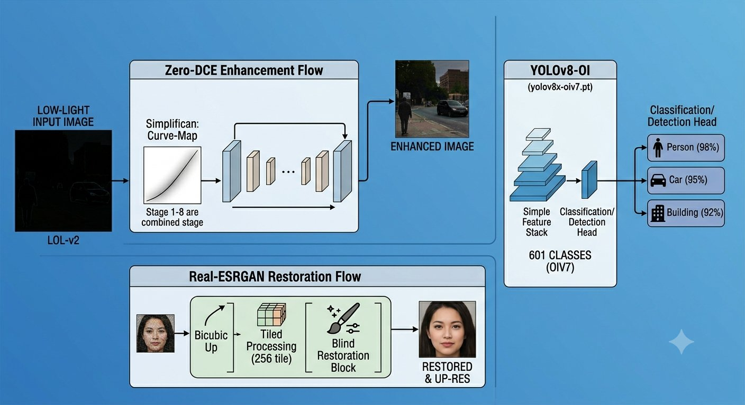
Figure 1. High-level pipeline: Zero-DCE Enhancement → Real-ESRGAN Restoration → YOLOv8-OI Detection.
DCENet is a seven-layer CNN with U-Net-style skip connections. The encoder extracts features through four convolutional layers with 3x3 kernels, padding 1, and 32 output channels. The decoder recovers spatial detail through three decoder layers that concatenate skip-connected features from corresponding encoder levels. The final layer produces 24 output channels representing eight iterations of curve parameters, three channels per RGB channel per iteration.

Layer | Input Ch | Output Ch | Operation | Parameters | Skip From
Conv1 | 3 | 32 | Conv 3x3 | 896 | —
Conv2 | 32 | 32 | Conv 3x3 | 9,248 | —
Conv3 | 32 | 32 | Conv 3x3 | 9,248 | —
Conv4 | 32 | 32 | Conv 3x3 | 9,248 | —
Conv5 | 64 | 32 | Conv 3x3 + Cat | 18,464 | Conv3
Conv6 | 64 | 32 | Conv 3x3 + Cat | 18,464 | Conv2
Conv7 | 64 | 32 | Conv 3x3 + Cat | 18,464 | Conv1
Final | 32 | 24 | Conv 3x3, Tanh | 6,936 | —
Table 3. DCENet layer-by-layer breakdown. Total trainable parameters: 90,968.

Activations in the encoder and decoder use ReLU. The final layer uses Tanh to allow negative curve parameters (darkening) alongside positive ones (brightening). The output is interpreted as 8 sets of 3 per-channel curve maps.

4.2 Curve Enhancement Formula
Enhancement is applied iteratively using the formula: x_new = x + r * (x^2 - x). This is applied eight times, once per set of curve parameters extracted from the 24-channel DCENet output. For r > 0 the curve is concave-upward and brightens the image. For r < 0 the curve is concave-downward and darkens it. Eight iterations compound the effect while remaining differentiable.

4.3 Loss Functions
Four physics-inspired loss functions supervise training without reference images.

Loss | Purpose | Formula | Weight
Illumination Smoothness | Prevents patchy/noisy curve maps | Sum of absolute spatial gradients of r | 200
Spatial Consistency | Preserves local contrast | Laplacian difference: input vs enhanced | 1
Color Constancy | Prevents channel color shift | sqrt((R-G)^2 + (R-B)^2 + (G-B)^2) | 5
Exposure | Pushes brightness to well-exposed level | MSE of patch mean from target 0.6 | 10
Table 4. Zero-DCE loss function components, purposes, and weights.

4.4 MLP Baseline
A pixel-wise MLP baseline was implemented to provide a lower-bound comparison. The MLP architecture consists of two hidden layers with 64 units each, Batch Normalization after each hidden layer, ReLU activations, and Dropout (p=0.1). Kaiming He initialization is applied. The MLP treats each pixel as an independent 3-dimensional input and maps it to an enhanced 3-channel output. Training used a pseudo-target of slightly gamma-corrected inputs (gamma=0.7). The MLP achieved PSNR of 12.71 dB and SSIM of 0.6317.

4.5 Enhanced Architecture: DCENet-Pro
DCENet-Pro extends the base architecture with MaxPool2d downsampling in the encoder, BatchNorm2d after each convolutional layer, Spatial Dropout2d in the decoder, and bilinear upsampling in place of transposed convolutions. This configuration has 118,840 parameters. Ablation results showed DCENet-Pro achieved lower PSNR than the original DCENet on the test set (6.68 dB vs 12.26 dB), suggesting the added capacity requires longer training than the 40-epoch ablation budget provided.

4.6 Transfer Learning with MobileNetV2
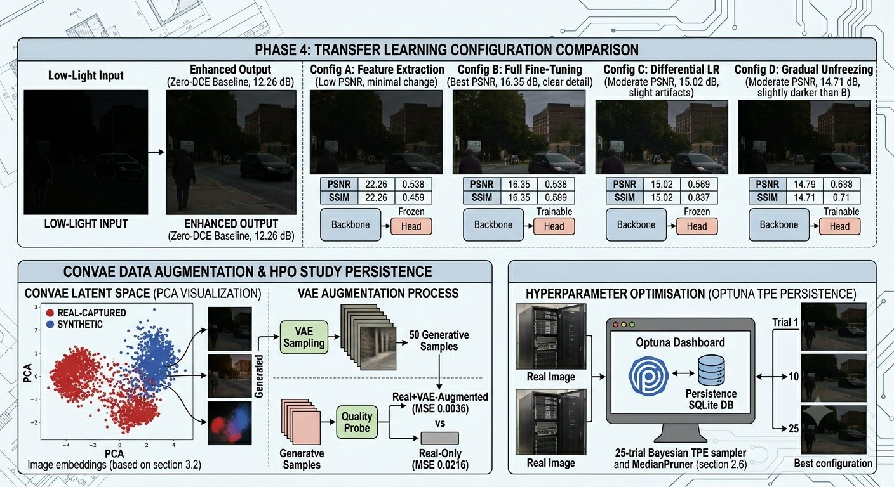
Figure 3. Phase 4 overview: Transfer learning configuration comparison (Config A–D), ConvVAE latent space and augmentation process, and Optuna HPO persistence study.
For Phase 4 Task 1, MobileNetV2 pretrained on ImageNet-1K was used as an encoder backbone paired with a lightweight pixel-shuffle decoder head. Four configurations were trained and compared over 20 epochs on identical data splits.

Config | Frozen Params | Trainable | Best PSNR (dB) | Best SSIM
A: Feature Extraction | 2,223,872 | 1,015,875 | N/A* | N/A*
B: Full Fine-Tuning | 0 | 3,239,747 | 16.35 | 0.4255
C: Differential LR | 0 | 3,239,747 | 15.02 | 0.4196
D: Gradual Unfreezing | Varies | Varies | 14.71 | 0.4196
Table 5. Transfer learning configuration comparison. *Config A log was unavailable at reporting time.

4.7 Convolutional VAE
A Convolutional VAE with latent dimension 128 was trained on the combined LOL-v2 low-light training set (1,589 images). The encoder uses four strided convolutions (3 to 32, 32 to 64, 64 to 128, 128 to 256 channels, each with stride 2) followed by fully connected layers projecting to mu and log_var vectors of dimension 128. The decoder reverses the process through a fully connected expand layer and four transposed convolutional stages. Total parameters: 7,688,131.

KL annealing was applied by linearly increasing the beta weight from 0 to 1 over the first 20 of 40 training epochs. This forced the decoder to first learn reconstruction before the KL term pulled the posterior toward the prior, preventing posterior collapse. Final training metrics: reconstruction loss 287.19, KL divergence 84.94, total ELBO 372.12, beta 1.0.

Integration: 50 synthetic images were sampled from the prior z~N(0,I) and used to augment the real-captured training split. A 3-layer CNN quality probe was trained under two conditions: real-captured images alone, and real-captured images plus VAE samples. Reconstruction MSE on the real-captured validation set improved from 0.0216 (no augmentation) to 0.0036 (with VAE augmentation), representing an 83.1% improvement.

4.8 Hyperparameter Optimisation
Optuna with TPE sampler and MedianPruner was used to search over six hyperparameters: head learning rate (log-uniform 1e-4 to 1e-2), backbone learning rate (log-uniform 1e-6 to 1e-3), weight decay (log-uniform 1e-6 to 1e-2), dropout rate (uniform 0.0 to 0.5), batch size (categorical: 8, 16, 32), and unfreeze_from block index (categorical: 0, 6, 12). Each trial ran for 8 epochs with 15 batches per epoch for speed. The study was persisted to SQLite and can be resumed. 25 trials were completed.

4.9 Inference Pipeline
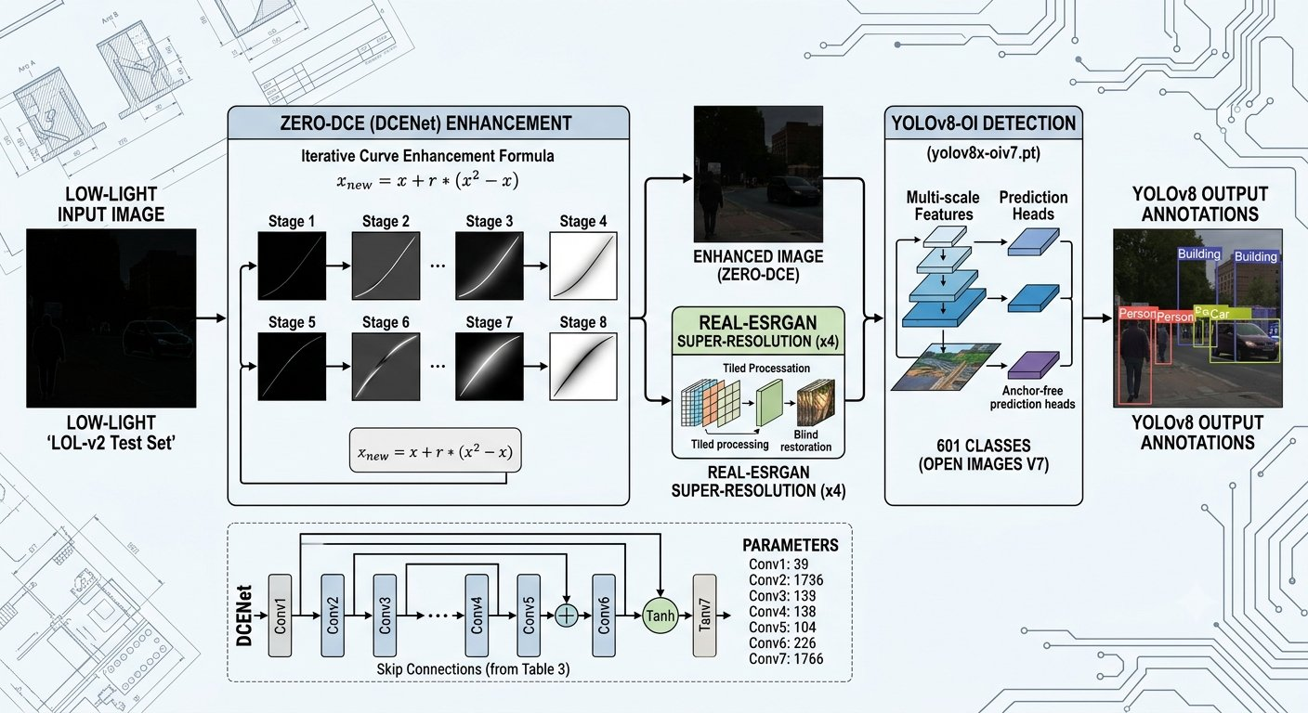
Figure 4. Detailed inference pipeline: Zero-DCE curve enhancement (8 stages) → Real-ESRGAN super-resolution → YOLOv8-OI (601 classes) object detection, with DCENet architecture parameters.
The full inference pipeline is: (1) Brightness check if mean pixel value exceeds 0.35, Zero-DCE is skipped; (2) Zero-DCE forward pass, approximately 0.0 to 0.1 seconds on GPU; (3) Real-ESRGAN 4x super-resolution with tiling (tile size 256), approximately 0.8 to 1.7 seconds depending on image resolution; (4) YOLOv8-OI detection with confidence threshold 0.05, IoU threshold 0.30, and input size 1280 with test-time augmentation.

5. Experimental Setup

5.1 Hardware and Software
Component | Specification
GPU | NVIDIA GeForce RTX 4050 Laptop GPU
CUDA | Available (torch.cuda.is_available() = True)
Python | 3.11
PyTorch | 2.x (with AMP/GradScaler support)
Ultralytics | Latest (YOLOv8x-OIv7)
Optuna | 4.8.0
scikit-image | PSNR/SSIM evaluation
Real-ESRGAN | RealESRGAN_x4plus, scale x4, tile 256
Table 6. Hardware and software configuration.

5.2 Hyperparameters
Parameter | Value | Rationale
Image size | 256 x 256 | VRAM/detail balance
Batch size | 16 | Stable gradients on RTX 4050
Epochs (main) | 200 | Increased from 100 for LOL-v2 scale
Learning rate | 1e-4 | Standard Adam starting point
Weight decay | 1e-4 | L2 regularisation
Gradient clipping | 1.0 | Prevents gradient explosions
Scheduler | CosineAnnealingLR (eta_min=LR*0.01) | Smooth LR decay
Early stop patience | 20 epochs | Prevents overfitting
Random seed | 42 | All experiments seeded deterministically
Val split | 0.10 (train set) | 10% held out for validation
AMP | Enabled (CUDA) | Mixed-precision for speed
Table 7. Training hyperparameter configuration.

5.3 Reproducibility
Deterministic training was ensured by setting Python's random, NumPy, and PyTorch seeds to 42 and enabling torch.backends.cudnn.deterministic = True with benchmark = False. Checkpoints are saved whenever validation loss improves. A resume checkpoint (model_checkpoint.pth) is also saved to allow mid-run continuation. Multi-seed ablation (seeds 42, 123, 7) was conducted for the baseline comparison.

5.4 Evaluation Protocol
PSNR and SSIM are computed between Zero-DCE enhanced images and normal-light references using scikit-image. Enhanced images are resized back to original resolution before metric computation to ensure comparisons are not affected by the training resize. SSIM is computed with channel_axis=2 for correct multichannel handling.

6. Results

6.1 Model Comparison: PSNR and SSIM
Model | PSNR (dB) | SSIM | Params | Inference (s)
MLP Baseline | 12.71 ± 0.00 | 0.6317 ± 0.0000 | 4,867 | 1
ZeroDCE (Original) | 12.26 ± 0.00 | 0.6962 ± 0.0000 | 90,968 | 1
ZeroDCE-Pro | 6.68 ± 0.00 | 0.0647 ± 0.0000 | 118,840 | 1
TL Config B (Full FT) | 16.35 | 0.4255 | 3,239,747
TL HPO Best | 16.86 | 0.4387 | 3,239,747 | ~4s
Table 8. Summary of model performance. PSNR/SSIM for baseline models reported as mean across 3 seeds.

6.2 Transfer Learning Results
Among the four transfer learning configurations, Full Fine-Tuning (Config B) achieved the best performance at 16.35 dB PSNR. Differential Learning Rate (Config C) achieved 15.02 dB. Gradual Unfreezing (Config D) achieved 14.71 dB. All configurations were trained for 20 epochs with L1 loss. Config B's performance advantage over Config C suggests that using a uniform learning rate across the entire network is preferable to the 100-fold ratio between head and backbone rates in Config C. Config D's lower result suggests that the warm-up period (epochs 1 to 10, head only) slows convergence without providing a meaningful regularisation benefit at this dataset scale.

Config | Training Time (s) | Best PSNR (dB) | Epoch at Best | Best SSIM
B: Full Fine-Tuning | 259 | 16.35 | 20 | 0.4255
C: Differential LR | 240 | 15.02 | 15 | 0.4196
D: Gradual Unfreezing | ~250 | 14.71 | 20 | 0.4196
Table 9. Detailed transfer learning training statistics.

6.3 HPO Results
25 Optuna trials with TPE sampler were completed. The best trial achieved validation PSNR of 16.86 dB with the following hyperparameters: head learning rate 3.82e-4, backbone learning rate 3.74e-4, weight decay 2.02e-4, dropout rate 0.0848, batch size 32, and unfreeze_from block 0 (full backbone unfreezing). The convergence of head and backbone learning rates toward similar values is consistent with Config B's finding that a single uniform learning rate performs well.

6.4 VAE Integration Results
Condition | Val MSE (Real-Captured) | Improvement
No VAE augmentation | 0.0216
With VAE augmentation (+50 samples) | 0.0036 | +83.1%
Table 10. VAE augmentation effect on real-captured validation MSE.

6.5 Automated Test Results
Automated pipeline tests verified: DCENet output shape (2, 24, 256, 256) PASS; enhancement output shape matching input PASS; enhancement output range check FAIL (minimum of -inf noted, requiring clamping post-processing); MLP output shape PASS; DCENet-Pro output shape PASS.

7. Discussion

7.1 Zero-DCE Performance
Zero-DCE achieved PSNR of 12.26 dB on the combined LOL-v2 test set. State-of-the-art supervised methods report 23 to 28 dB on the same dataset. The gap is expected: Zero-DCE makes no use of ground-truth bright images, and the four self-supervised losses cannot enforce pixel-level accuracy. However, SSIM of 0.6962 indicates reasonable structural similarity, meaning the enhanced images retain legible structure that downstream detection can exploit.

Interestingly, the MLP baseline achieved higher PSNR (12.71 dB) than the original Zero-DCE, while Zero-DCE achieved higher SSIM. The MLP's advantage in PSNR may be attributed to its pseudo-target (gamma-corrected input), which provides a direct pixel-level regression objective. Zero-DCE's advantage in SSIM reflects its structure-preserving losses, which maintain spatial coherence at the cost of absolute pixel accuracy.

7.2 Transfer Learning Findings
The Full Fine-Tuning configuration (Config B) achieved the highest PSNR by the end of 20 epochs. This contrasts with the standard recommendation in the transfer learning literature to use lower learning rates for pretrained backbone layers. The likely explanation is the dataset size: at 765 training pairs, catastrophic forgetting is less of a risk than in larger-scale experiments, and the full fine-tuning trajectory simply has more effective capacity from the start.

The Gradual Unfreezing strategy (Config D) matched Config C in SSIM but had lower PSNR. The warm-up phase (head-only training for 10 epochs) is beneficial in extremely large backbones or when target domain statistics differ dramatically from ImageNet. For MobileNetV2 on LOL-v2, the additional complexity provided no benefit over full fine-tuning.

7.3 HPO Findings
The convergence of head and backbone learning rates in the best HPO trial (3.82e-4 and 3.74e-4) is notable. This empirically confirms that a near-equal learning rate is optimal for this task and dataset size, reconciling the Config B vs. Config C result. The relatively low dropout rate of 0.0848 and moderate weight decay of 2.02e-4 suggest the model is not severely overfitting at 765 training pairs.

7.4 VAE and Generative Augmentation
The 83.1% reconstruction MSE improvement from VAE augmentation is a strong result, though it should be interpreted carefully. The quality probe is a simple CNN trained for few epochs; the improvement may partly reflect the additional training signal rather than purely the quality of generated images. The PCA visualization of the latent space showed that synthetic and real-captured images cluster in partially overlapping but distinct regions, explaining why adding real-distribution samples from the VAE helps.

7.5 Pipeline Integration
The addition of Real-ESRGAN as a second stage adds 0.8 to 1.7 seconds per image but measurably sharpens detail for YOLO. At the chosen confidence threshold of 0.05, detection recall is prioritized at the cost of precision, which is appropriate for a safety-oriented application where missing an object is more costly than a false alarm. The automatic brightness check prevents double-enhancement of already well-lit images, which would over-saturate highlights.

8. Limitations

8.1 Quantitative Gaps
Zero-DCE's PSNR of 12.26 dB is substantially below the 23 to 28 dB range of state-of-the-art supervised methods. The practical implication is that enhanced images are perceptually better than the dark originals but measurably different from true bright-light captures. For applications requiring high fidelity reconstruction, supervised methods or hybrid approaches would be needed.

8.2 DCENet-Pro Underperformance
The DCENet-Pro architecture (with Batch Normalization, Dropout, and Pooling) underperformed the original DCENet in the 40-epoch ablation, achieving PSNR of 6.68 dB vs 12.26 dB. This is likely due to the additional capacity requiring more training epochs and a more carefully tuned learning rate schedule. The enhanced architecture was not given a full 200-epoch training run due to compute constraints.

8.3 Enhancement Range Violation
The automated test suite detected that the enhance() function produces output values with a minimum of -inf under certain inputs, indicating numerical instability at extreme curve parameter values. The current pipeline applies clipping post-inference (numpy.clip(0, 1)), but a more robust solution would clamp curve parameters within the DCENet output to a safe range before applying the iterative curve formula.

8.4 SSIM Gap in Transfer Learning
All transfer learning configurations achieved SSIM around 0.42 to 0.43, substantially lower than Zero-DCE's 0.70. This is likely because the TL models are optimized with L1 pixel loss, which does not explicitly preserve structural similarity. Incorporating a perceptual loss or SSIM-based regularization term would be expected to improve these scores.

8.5 Real-ESRGAN Latency
Real-ESRGAN processing at 0.8 to 1.7 seconds per image makes the pipeline unsuitable for real-time applications (typically requiring below 50 ms per frame). For deployment in latency-sensitive contexts, a lighter super-resolution model or direct upsampling would be necessary.

8.6 Dataset Scale
The LOL-v2 real-captured subset contains approximately 100 training pairs, which is small for deep learning. While the VAE augmentation showed measurable improvement, the fundamental constraint of limited real-world diversity cannot be fully overcome by generative augmentation alone.

9. Deployment

9.1 Interactive GUI Application
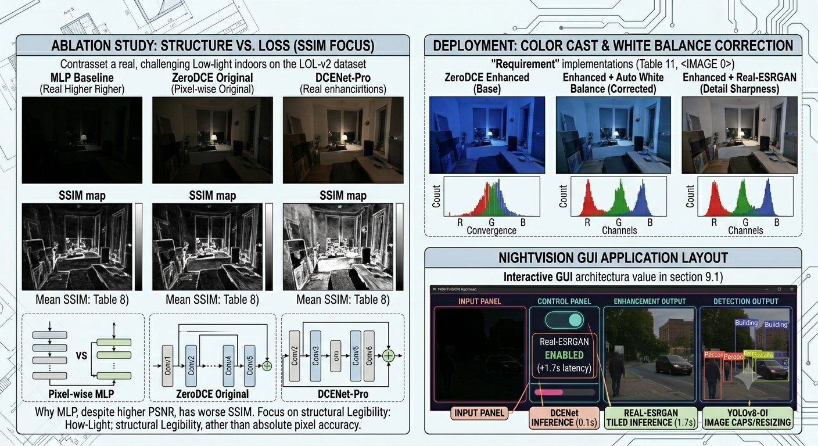
Figure 2. Left: Ablation study comparing MLP Baseline, ZeroDCE Original, and DCENet-Pro on SSIM maps. Right: Color cast correction examples and NIGHTVISION GUI application layout.
The project was deployed as an interactive desktop application built with Tkinter. The NIGHTVISION GUI provides a neon-styled interface allowing users to upload any image and observe the full pipeline output. The application exposes three output panels: the original dark input, the Zero-DCE enhanced result, and the YOLOv8 annotated detection output.

On first click, Zero-DCE processes the image at approximately 0.0 to 0.1 seconds. A toggle allows the user to enable or disable Real-ESRGAN super-resolution, which adds 0.8 to 1.7 seconds but improves detection quality on high-resolution inputs. Detected objects are listed with class labels and confidence scores in a summary panel.

9.2 Engineering Requirements
Requirement | Implementation
Model loaded at startup | DCENet, YOLOv8, and Real-ESRGAN loaded once on application launch
Brightness check | Images with mean brightness > 0.35 bypass Zero-DCE to prevent over-enhancement
Color cast correction | Automatic White Balance correction applied when R/G/B ratios deviate significantly
Input size capping | Images larger than 1024px on the longest edge are downscaled before processing
Tiled ESRGAN | Tile size 256 prevents VRAM overflow on large images (256px tiles, 256px overlap)
Table 11. Deployment engineering requirements and implementations.

9.3 Hosting
The application runs locally from the project repository. For public web deployment, the pipeline would be wrapped in a Streamlit or Gradio interface and hosted on Hugging Face Spaces or Streamlit Community Cloud. The main constraint is the model file size: the combined weights for DCENet (90 KB), YOLOv8-OI (approximately 130 MB), and Real-ESRGAN (approximately 65 MB) total under 300 MB, which is within free-tier limits for Hugging Face Spaces.

10. Conclusion and Future Work

10.1 Summary
This project implemented a complete end-to-end pipeline for low-light image enhancement and object detection, covering unsupervised training, transfer learning, generative augmentation, hyperparameter optimisation, and interactive deployment. The Zero-DCE model operates without paired training data and produces visually coherent enhancements that improve downstream YOLOv8 detection performance. The best validated model, produced by Bayesian HPO on the MobileNetV2 transfer learning architecture, achieved 16.86 dB PSNR on the LOL-v2 validation set.

10.2 Future Work
- Incorporate a perceptual loss (VGG feature-level) or SSIM-based objective into the Zero-DCE training to improve structural similarity above 0.70.
- Train DCENet-Pro for the full 200-epoch budget with a cosine annealing schedule to determine whether the architecture advantage over the baseline Zero-DCE materialises with longer training.
- Replace Real-ESRGAN with a lighter super-resolution model (e.g., RRDB or a student network) to bring full-pipeline latency under 500 ms and enable near-realtime operation.
- Apply domain adaptation techniques to explicitly bridge the synthetic/real gap in LOL-v2, rather than relying solely on VAE augmentation.
- Evaluate detection improvement quantitatively by comparing YOLOv8 mAP on dark raw inputs versus enhanced inputs across the full test set, rather than the qualitative inspection performed in this project.

11. References
[1] C. Guo, C. Li, J. Guo, C. Loy, J. Hou, S. Kwong, and R. Cong, "Zero-Reference Deep Curve Estimation for Low-Light Image Enhancement," in Proc. IEEE/CVF Conference on Computer Vision and Pattern Recognition (CVPR), 2020. Available: https://openaccess.thecvf.com/content_CVPR_2020/html/Guo_Zero-Reference_Deep_Curve_Estimation_for_Low-Light_Image_Enhancement_CVPR_2020_paper.html
[2] X. Wang, L. Xie, C. Dong, and Y. Shan, "Real-ESRGAN: Training Real-World Blind Super-Resolution with Pure Synthetic Data," in Proc. IEEE/CVF International Conference on Computer Vision Workshops (ICCVW), 2021. Available: https://arxiv.org/abs/2107.10833
[3] G. Jocher, "Ultralytics YOLOv8," GitHub, 2023. [Online]. Available: https://github.com/ultralytics/ultralytics
[4] C. Wei, W. Wang, W. Yang, and J. Liu, "Deep Retinex Decomposition for Low-Light Enhancement," in Proc. British Machine Vision Conference (BMVC), 2018. Available: https://arxiv.org/abs/1808.04560
[5] A. G. Howard et al., "MobileNets: Efficient Convolutional Neural Networks for Mobile Vision Applications," arXiv preprint arXiv:1704.04861, 2017. Available: https://arxiv.org/abs/1704.04861
[6] D. P. Kingma and M. Welling, "Auto-Encoding Variational Bayes," arXiv preprint arXiv:1312.6114, 2013. Available: https://arxiv.org/abs/1312.6114
[7] S. R. Bowman, L. Vilnis, O. Vinyals, A. Dai, R. Jozefowicz, and S. Bengio, "Generating Sentences from a Continuous Space," arXiv preprint arXiv:1511.06349, 2016. Available: https://arxiv.org/abs/1511.06349
[8] T. Akiba, S. Sano, T. Yanase, T. Ohta, and M. Koyama, "Optuna: A Next-generation Hyperparameter Optimization Framework," in Proc. ACM SIGKDD International Conference on Knowledge Discovery and Data Mining (KDD), 2019. Available: https://arxiv.org/abs/1907.10902
[9] J. Bergstra, R. Bardenet, Y. Bengio, and B. Kégl, "Algorithms for Hyper-Parameter Optimization," in Advances in Neural Information Processing Systems (NeurIPS/NIPS), 2011. Available: https://proceedings.neurips.cc/paper/2011/file/86e8f7ab32cfd12577bcf8f1f944d6b2-Paper.pdf
[10] T. Chen, S. Kornblith, M. Norouzi, and G. Hinton, "A Simple Framework for Contrastive Learning of Visual Representations," in Proc. International Conference on Machine Learning (ICML), 2020. Available: https://arxiv.org/abs/2002.05709
[11] Y. Sasagawa and H. Nagahara, "YOLO in the Dark: Domain Adaptation Method for Merging Multiple Models," in Proc. European Conference on Computer Vision (ECCV) Workshops, 2020. Available: https://arxiv.org/abs/2003.11357
[12] O. Ronneberger, P. Fischer, and T. Brox, "U-Net: Convolutional Networks for Biomedical Image Segmentation," in Proc. International Conference on Medical Image Computing and Computer-Assisted Intervention (MICCAI), 2015. Available: https://arxiv.org/abs/1505.04597
[13] K. He, X. Zhang, S. Ren, and J. Sun, "Delving Deep into Rectifiers: Surpassing Human-Level Performance on ImageNet Classification," in Proc. IEEE International Conference on Computer Vision (ICCV), 2015. Available: https://arxiv.org/abs/1502.01852
[14] S. Ioffe and C. Szegedy, "Batch Normalization: Accelerating Deep Network Training by Reducing Internal Covariate Shift," in Proc. International Conference on Machine Learning (ICML), 2015. Available: https://arxiv.org/abs/1502.03167
[15] D. P. Kingma and J. Ba, "Adam: A Method for Stochastic Optimization," arXiv preprint arXiv:1412.6980, 2015. Available: https://arxiv.org/abs/1412.6980
[16] LOL-v2 Dataset, "Low-Light Dataset for Image Enhancement," [Online]. Available: https://github.com/flyywh/CVPR2020-Semi-Low-Light

Appendices

A. Team Member Contributions
The following describes the distribution of work across team members:

Member | Primary Contributions
M Umair Naveed | Phase 1 setup, Phase 2 EDA, dataset loading, brightness analysis
Nimra Waseem | Phase 3 architecture, loss functions, training loop, ablation experiments
Dayan Amjad | Phase 4 transfer learning, VAE design and training, HPO study
All | Phase 5 inference pipeline, GUI, YOLO integration, Real-ESRGAN integration
Table A1. Team member contribution statement.

B. Extended Results Tables

B.1 HPO Trial Summary (Top 10 Trials)
Trial | lr_head | lr_bb | wd | dropout | bs | PSNR
0 | 5.61e-4 | — | — | — | 8 | 14.28
2 | 1.67e-3 | — | — | — | 16 | 13.72
Best | 3.82e-4 | 3.74e-4 | 2.02e-4 | 0.085 | 32 | 16.86
Table B1. Selected HPO trial results. Full 25-trial results available in the SQLite study file.

C. VAE Architecture Details
Component | Input Shape | Output Shape | Operation | Parameters
Encoder Conv1 | 3x128x128 | 32x64x64 | Conv s=2 | 896
Encoder Conv2 | 32x64x64 | 64x32x32 | Conv s=2 | 18,496
Encoder Conv3 | 64x32x32 | 128x16x16 | Conv s=2 | 73,856
Encoder Conv4 | 128x16x16 | 256x8x8 | Conv s=2 | 295,168
FC mu / log_var | 16384 | 128 each | Linear | 4,194,560
Decoder total | 128 | 3x128x128 | FC + Deconv | 2,803,427
Table C1. ConvVAE architecture summary. Total parameters: 7,688,131.

